NASHRA AZHAR
FA24B1-CS-081
LAB 06 OS
EXAMPLES FROM MANUAL

Example 1 (creat)

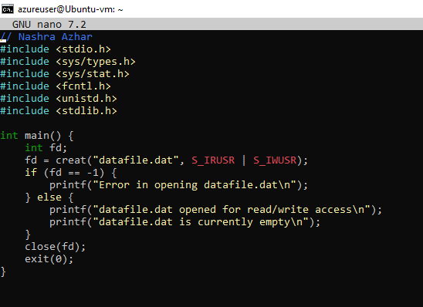

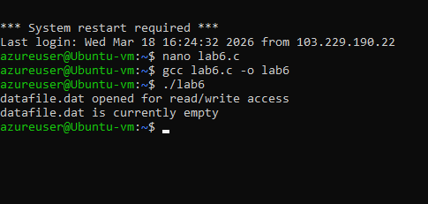

Example 2 (open/close):

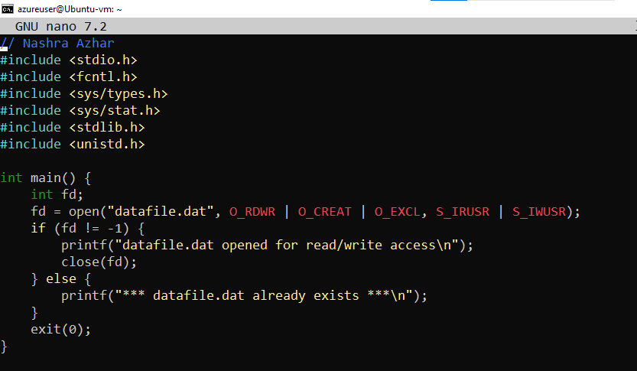

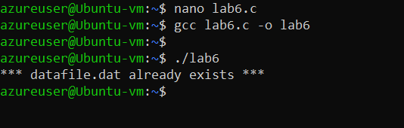

Example 3 (read/write/lseek):

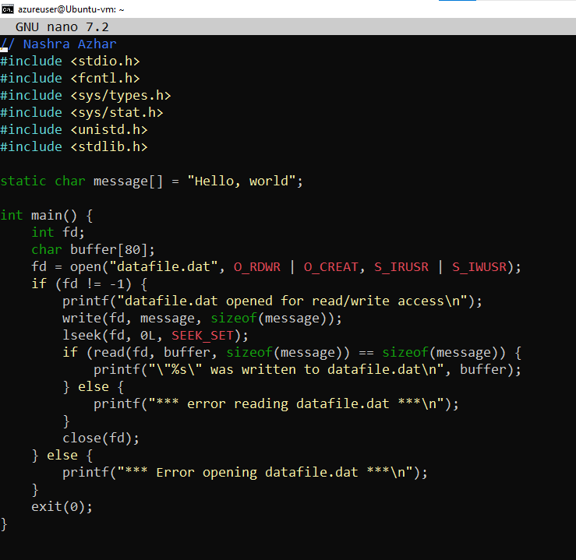

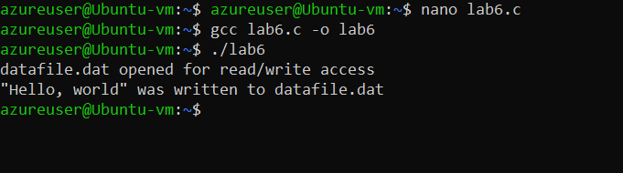

Example Basic File Creation:

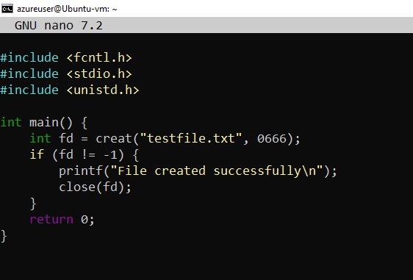

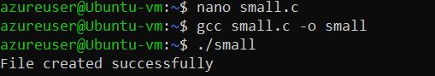

Examle: Simple Open Check

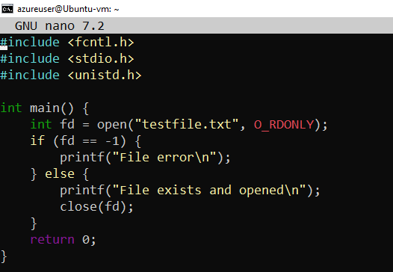

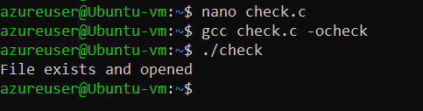

Example:

